DNA extraction from saliva – virtual simulation
- Methodology
- Put on PPE -Before beginning the experiment, put on gloves, a lab coat and safety goggles
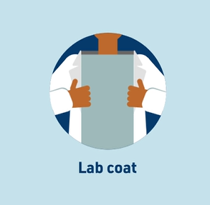
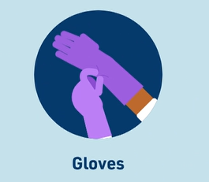
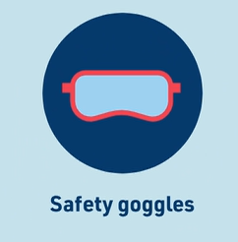

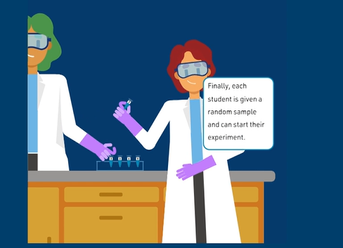
- Collect tissue: Saliva samples are collected from each individual.

- Lyse the cells: Cells are broken open to release the cell contents.
  - Select the heat block and set the temperature to 50°C using the up arrow button. Continue to the next steps while the heat block warms up by pressing the "Back to lab" button.
  - Select the P1000 micropipette and select the volume pop-up to open the volume setting option. Set the P1000 micropipette to 500 uL using either the +/- buttons or the text box. Then click "Back to lab."
  - Open the P1000 tip box and move the P1000 micropipette over the P1000 tip box to attach a tip then close the P1000 tip box.
  - Open the Lysis buffer tube. Pick up the micropipette and place it so that the tip is in the Lysis buffer tube. Draw up 500 μl of lysis buffer by pressing the plunger down until it reaches the first stop and then slowly releasing it.
  - Open the Sample 1 tube. Dispense the lysis buffer into the Sample 1 tube by holding the plunger down until it reaches the second stop. Mix the Sample 1 tube gently by inversion 10 times.
  - Set the P1000 micropipette to 500 μl and select “Back to lab”.
  - Open the Sample 1 tube. Draw up 500 μl of the solution by pressing the plunger down until it reaches the first stop and then slowly releasing it.
  - Dispense the solution into the Sample 1: Purification tube by holding the plunger down until it reaches the second stop.
  - Heat the Sample 1 mixture, which facilitates cell lysis and protein denaturation. Select the timer to open its controls. Use the up arrow button to set the timer to 1 hour and 30 minutes and press "Start". Click "Back to lab" when you are done.
  - Open the heat block menu and select “Remove tubes” to remove the Sample 1: Purification tube and return it to the tube rack.
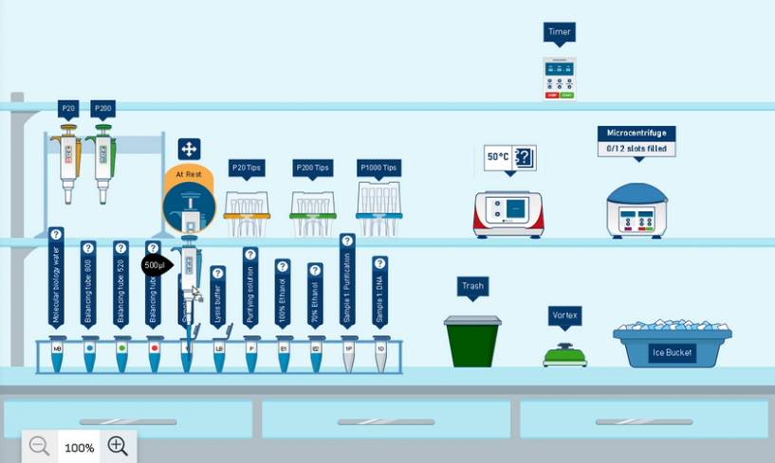
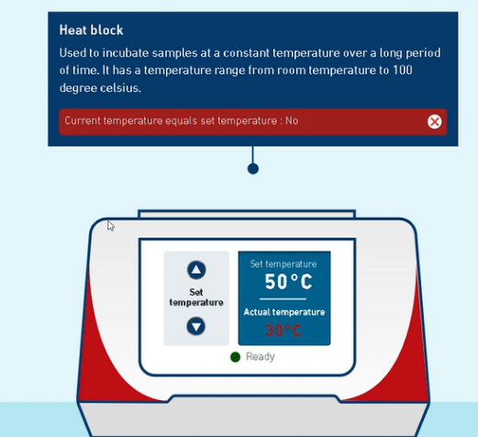

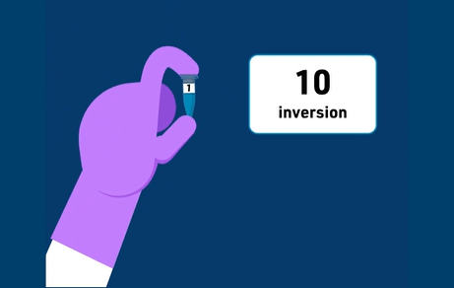
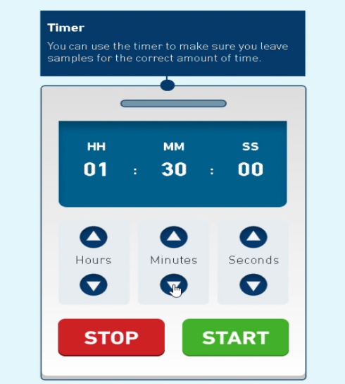

- Clear the lysate: Separate the DNA from the rest of the cell contents.
  - Set the P20 micropipette to 20 μl and select “Back to lab.”
  - Open the Purifying solution tube. Draw up 20 μl of the purifying solution by pressing the plunger down until it reaches the first stop and then slowly releasing it.
  - Open the Sample 1: Purification tube and dispense the purifying solution into the Sample 1: Purification tube by holding the plunger down until it reaches the second stop.
  - Move the Sample 1: Purification tube to the vortex where it’s mixed for 10 seconds.
  - Place the Sample 1: Purification tube in the ice bucket.
  - Select the timer to open its controls. Use the up arrow button to set the timer to 10 minutes and press "Start". Click "Back to lab" when you are done. Remove the Sample 1: Purification tube from the ice bucket and place it on the tube rack after 10 mins.
  - Centrifuge the Sample 1 mixture and separate the insoluble cellular components, like proteins and lipids, from the soluble components like DNA. Use the arrow buttons to set the microcentrifuge to spin at 15,000 x g for 5 minutes, then press "Start". Click "Back to lab" when you are done. Make sure the balancing tube you select matches the volume in your sample tube.
  - Examine the Sample 1: Purification tube and identify the pellet at the bottom of the tube. If you do not see a pellet, revisit the previous protocol steps and check that you completed all the steps correctly. You may need to repeat the centrifugation steps.
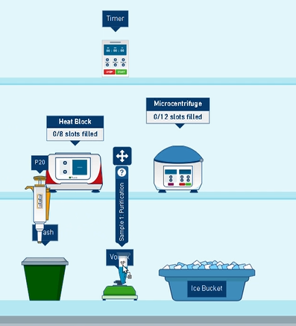
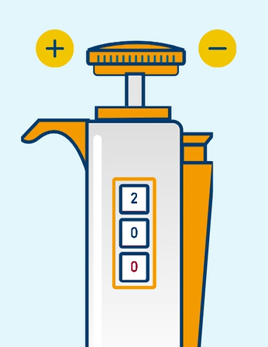
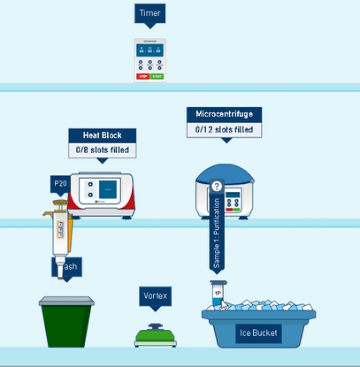

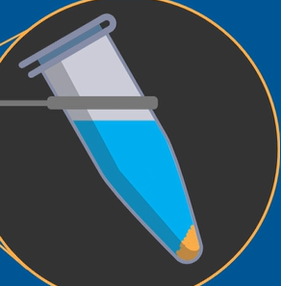
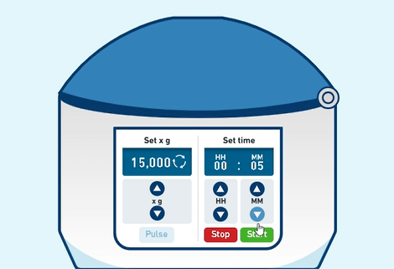
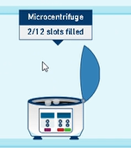

- Precipitate the DNA: Bring the DNA out of solution.
  - Transfer the liquid supernatant from Sample 1, which contains the DNA, to a new tube.
  - Add 400 μl of 100% ethanol, which reduces the water content in the solution and precipitates DNA out of solution. Mix the Sample 1: DNA tube gently by inversion 10 times
  - set the microcentrifuge to spin at 15000 x g for 2 minutes, then press "Start". Centrifuge the Sample 1: Ethanol mixture and collect the precipitated DNA at the bottom of the tube.
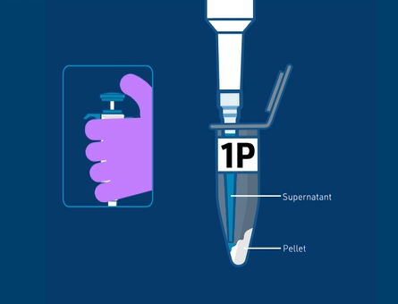
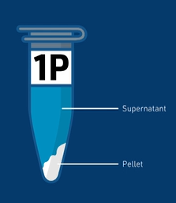
  - Examine the Sample 1: DNA tube and identify the pellet at the bottom of the tube. If you do not see a pellet, revisit the previous protocol steps and check that you have completed all the steps correctly. You may need to repeat the centrifugation steps.

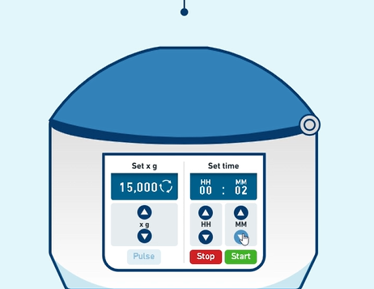
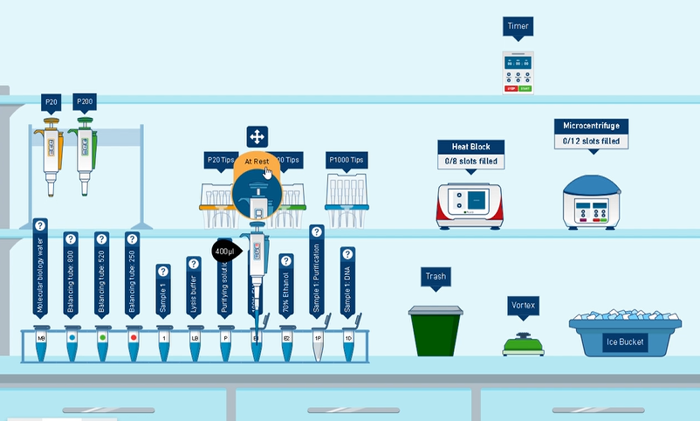

- Wash the DNA: Remove any remaining impurities.
  - Remove and discard the liquid supernatant, and keep the pellet, which contains the precipitated DNA.
  - Add 250 μl of 70% ethanol to the DNA pellet, which helps keep DNA out of solution, and also to remove any lingering impurities.
  - Set the microcentrifuge to spin at 15000 x g for 2 minutes, then press "Start". This keeps DNA in the pellet and removes any impurities.
  - Examine the Sample 1: DNA tube and identify the pellet at the bottom of the tube.
  - Remove the liquid supernatant containing the ethanol wash and any lingering impurities, which keeps the DNA pellet undisturbed.
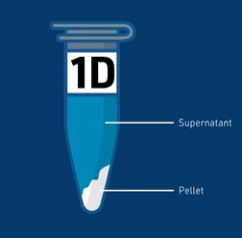
  - Allow the remaining drops of ethanol solution to evaporate from the DNA pellet in the tube. Set the timer for 30 minutes and start the timer to let the DNA pellet dry at room temperature.
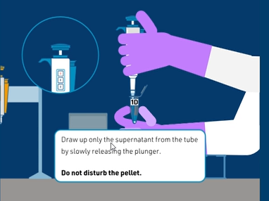

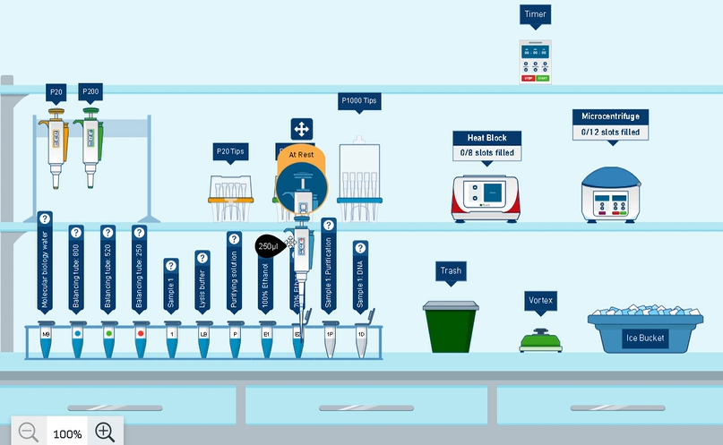
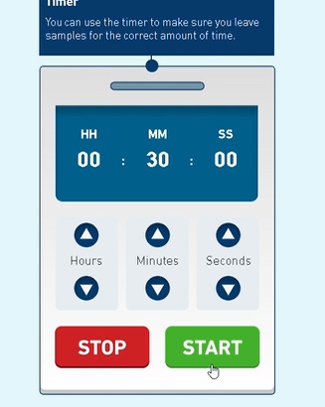

- Resuspend the DNA: Dissolve the DNA pellet in water
  - Add 100 μl of molecular biology water to the tube containing the DNA pellet.
  - Use the vortex to mix the tube containing the DNA pellet, which fully dissolves the DNA in water.
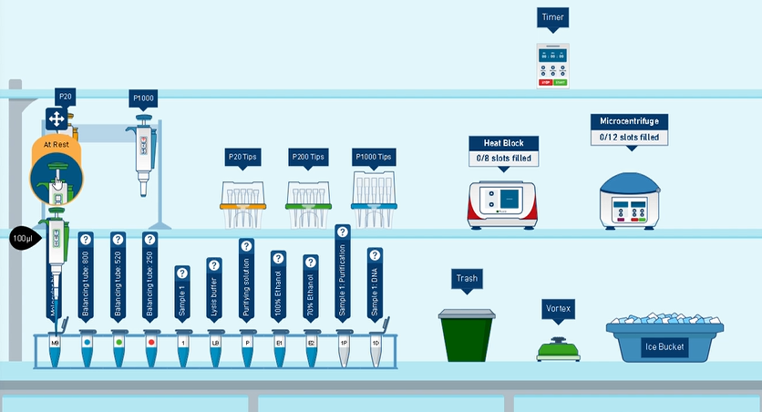
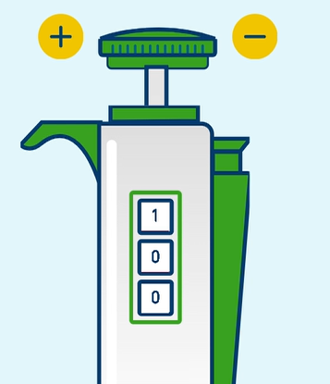
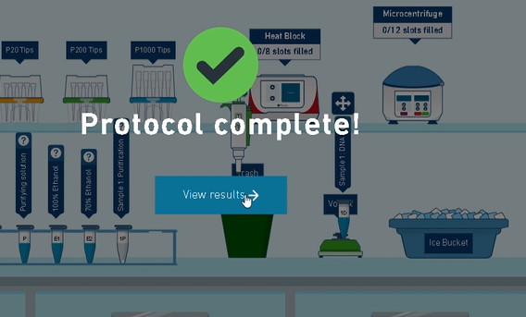

- Result
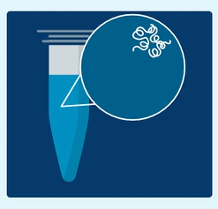
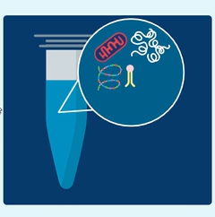

Actual result Ideal result
DNA was isolated from the cells present in the saliva.
- Conclusion:
This simulation explored how to do the following:
- Complete the lab procedures necessary to collect DNA samples,
- Demonstrate proper micropipetting technique
- Use lab equipment, including the centrifuge and the vortex,
- Extract and observe a pellet of DNA

